# Project Design Phase-II Technology Stack (Architecture & Stack)

|  |  |
| --- | --- |
| Date | 09 November 2022 |
| Team ID | PNT2022TMID12567 |
| Project Name | Predicting the energy output of wind turbine based on  weather conditions |

**Technical Architecture**

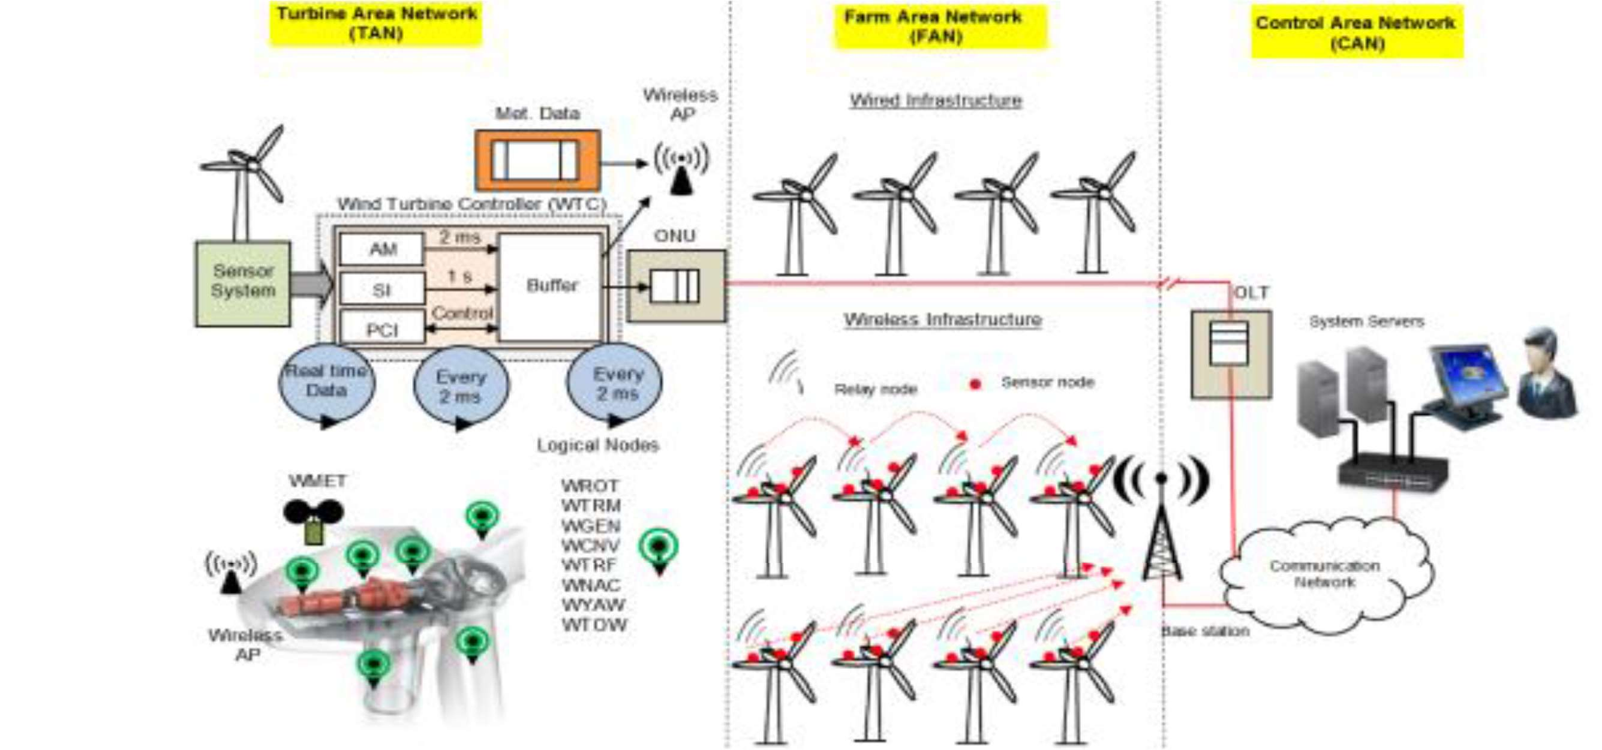

# Guidelines:

The proposed communication network architecture for the Smart-WPF consists of three networks: the turbine area network (TAN), the farm area network (FAN), and the control area network (CAN). It consists of hierarchical architectures where Level 1 is a sensor network in a single wind turbine, Level 2 is the wind turbine-to-wind turbine interaction in the WPF, Level 3 is the local control center to wind turbine interaction, and Level 4 is the farm-to- farm interaction to optimize grid operation. In order to implement hierarchical network architectures, a hybrid communication solution is considered. EPON-based architecture represents a wired solution, while ZigBee-Pro is considered for the wireless solution. In this work, Levels 1 and 2 are explained in more detail, while Levels 3 and 4 are out the scope of this work.

# Table 1 – Components and Technologies:

|  |  |  |  |
| --- | --- | --- | --- |
| **S.No** | **Component** | **Description** | **Technology** |
| 1 | User Interface | This is used by the user for interacting with the system to  know about the services provided by system. | HTML, CSS, Angular Js. |
| 2 | Weather Data  collector | This weather data collector is used to collect the real time  weather data in the environment. | Sensors, wired and  wireless network |
| 3 | Symbolic Regression (Machine Learning  Model) | To deal with interaction of the different parameters. | Genetic Programming Data Modeler. |
| 4 | Database | Used to store the collected and examine weather  condition and energy output. | MySQL, NoSQL, etc. |
| 5 | File Storage | To store the data files in the databases for future  references. | Local or Global File System  or IBM Storage. |
| 6 | External API | This application programming interfaces is used to know about the energy output based on every weather  condition. | Weather conditions obtained and their energy  output. |
| 7 | Infrastructure (Server/Cloud) | The whole system is applied and stored in server for easy access and retrieved. | Data Storage Server or IBM Cloud Servers |

**Table-2: Application Characteristics:**

|  |  |  |  |
| --- | --- | --- | --- |
| **S.No** | **Characteristics** | **Description** | **Technology** |
| 1 | Open-Source Frameworks | The open source framework used in this system is flexible and it includes R, python etc.. | IBM Open source Tools and databases. |
| 2 | Security Implementations | The data stored in the database when shared with industries are encrypted and shared as encrypted data to avoid the access of data by third party people. | SHA-256,  Encryptions, IAM Controls, OWASP etc. |
| 3 | Scalable Architecture | The architecture used here is a 3tier architecture where a middleware is present to carry out the communication between client and server. | 3tier architecture. |
| 4 | Availability | The system is designed in a way that It can handle traffic in a better way and thus helps the system available for users at any time. | Network traffic analysis tools. |
| 5 | Performance | The system can efficiently handle a higher number of request and can also uses catch buffer to store and retrieve the data in a easier way. | Methods like Confusion Matrix F1 score, Precision  – Recall curve etc. |